**DAILY ONLINE ACTIVITIES SUMMARY**

|  |  |  |  |  |  |  |  |  |
| --- | --- | --- | --- | --- | --- | --- | --- | --- |
| **Date:** | **02-07-2020** | | | | | **Name:** | **Deril Quadras** | |
| **Sem & Sec** | **8 A** | | | | | **USN:** | **4AL16CS031** | |
| **Online Test Summary** | | | | | | | | |
| **Subject** | | **-** | | | | | | |
| **Max. Marks** | | **-** | | **Score** | | | **-** | |
| **Certification Course Summary** | | | | | | | | |
| **Course** | **AWS Compute Service Overview.** | | | | | | | |
| **Certificate Provider** | | | **AWS** | | **Duration** | | | **30 mins** |
| **Coding Challenges** | | | | | | | | |
| **Problem Statement:**   1. **Write a C Program to string without vowels** | | | | | | | | |
| **Status: Solved** | | | | | | | | |
| **Uploaded the report in Github** | | | | | **Yes** | | | |
| **If yes Repository name** | | | | | **Derilquadras/online_c_coding_repository** | | | |
| **Uploaded the report in slack** | | | | | **Yes** | | | |

Online Test Details:

Not Conducted

Certification Course Details:

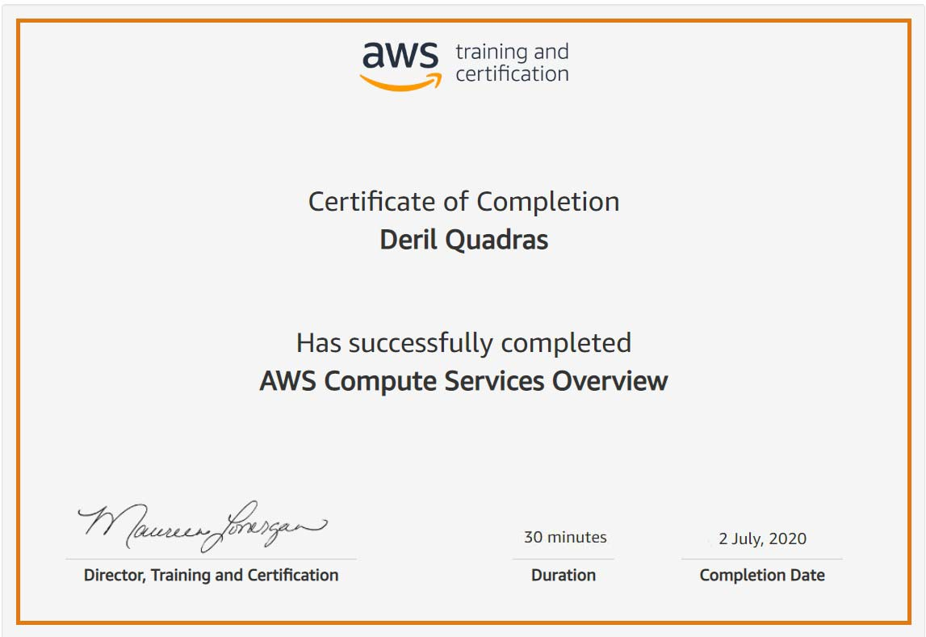

Coding Challenges Details:

**PROGRAM 1 .**

**// string without vowels**

**#include <stdio.h>**

**#include <string.h>**

**int main()**

**{**

**char str[50];**

**int len = 0, i = 0, k = 0, count = 0;**

**printf("Enter the string : ");**

**scanf("%s",str);**

**printf("%s",str);**

**len=strlen(str);**

**count = len;**

**for (i = 0; i < len;)**

**{**

**switch (str[i])**

**{**

**case 'a':**

**case 'A':**

**case 'e':**

**case 'E':**

**case 'i':**

**case 'I':**

**case 'o':**

**case 'O':**

**case 'u':**

**case 'U':**

**for (k = i; k < count; k++)**

**{**

**str[k] = str[k + 1];**

**}**

**count--;**

**break;**

**default:**

**i++;**

**}**

**}**

**str[count] = '\0';**

**printf("\nstring after removing vowels is : %s", str);**

**return 0;**

**}**